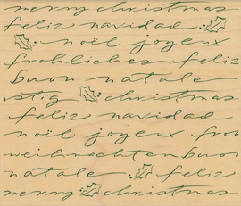

A Special Christmas Celebration
of
Christ Presbyterian Church
✵
Friday, December 16, 2005
7:oo pm



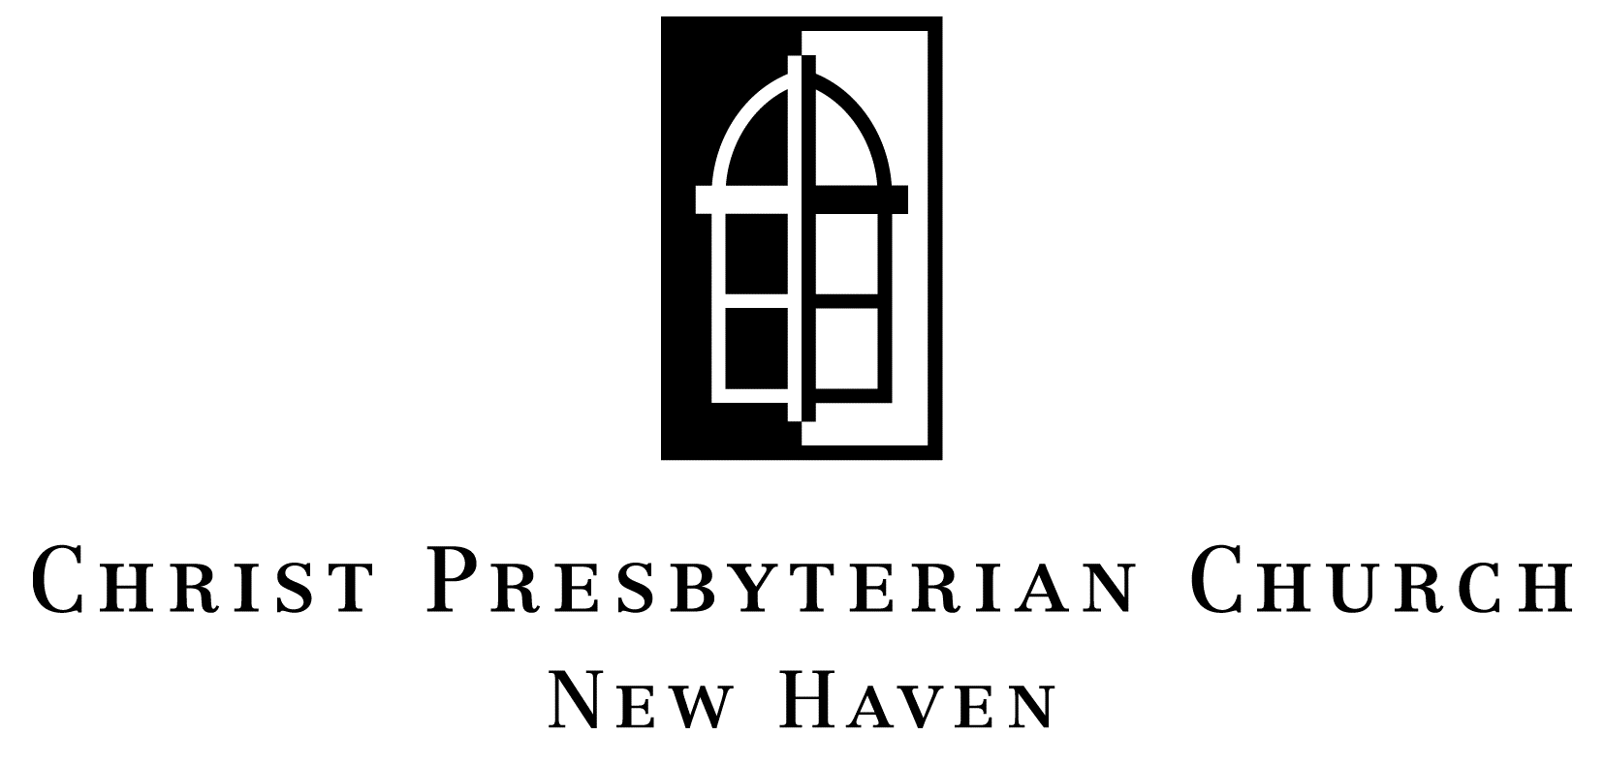

Christ Presbyterian Church
Invites you

✵
Christmas Festival of Lessons & Carols
A Gift for the Nations –
come celebrate Christ’s birth with us
Friday, December 16th, 7:00 pm

Christmas Eve Service
Saturday, December 24th at 6:30 pm

Christmas Day
Sunday, December 25th one service at 11:15 am
no Sunday School that morning
✵
135 Whitney Avenue ▪ New Haven
777-6960 ▪ www.christpresnewhaven.org

